Lambda Expression:

Lambda Expression basically express instances of functions interfaces

(An interface with a single abstract method is called a functional interface).

Lambda Expressions in java are the same as lambda function which are the short block of code that accepts input as parameters and returns a resultant value.

why:

Less Code

Easy to implement anonymous inner classes

parameters to methods

**Java Lambda Expression Example**

// Java program to demonstrate lambda expressions

// to implement a user defined functional interface.

// A sample functional interface (An interface with

// single abstract method

interface FuncInterface

{

// An abstract function

void abstractFun(int x);

// A non-abstract (or default) function

default void normalFun()

{

System.out.println("Hello");

}

}

class Test

{

public static void main(String args[])

{

// lambda expression to implement above

// functional interface. This interface

// by default implements abstractFun()

FuncInterface fobj = (int x)->System.out.println(2*x);

// This calls above lambda expression and prints 10.

fobj.abstractFun(5);

}

}

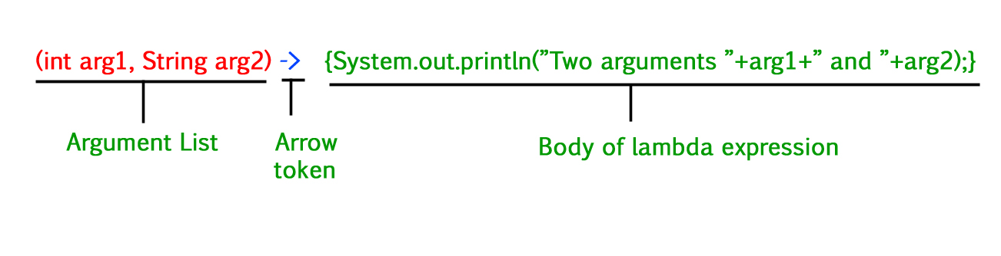

**Lambda Expression Syntax**

lambda operator -> body

lambda operator -> body

**Lambda Expression Parameters**

There are three Lambda Expression Parameters are mentioned below:

1. Zero Parameter
2. Single Parameter
3. Multiple Parameters

**1. Lambda Expression with Zero parameter**

() ->System.out.println(“Zero parameter lambda”);

**2. Lambda Expression with Single parameter**

(p)-> System.out.println(“one parameter:”+p);

It is not mandatory to use parentheses if the type of that variable can be inferred from the context

// A Java program to demonstrate simple lambda expressions

import java.util.ArrayList;

class Test {

public static void main(String args[])

{

// Creating an ArrayList with elements

// {1, 2, 3, 4}

ArrayList<Integer> arrL = new ArrayList<Integer>();

arrL.add(1);

arrL.add(2);

arrL.add(3);

arrL.add(4);

// Using lambda expression to print all elements

// of arrL

arrL.forEach(n -> System.out.println(n));

// Using lambda expression to print even elements

// of arrL

arrL.forEach(n -> {

if (n % 2 == 0)

System.out.println(n);

});

}

}

1. **Lambda Expression with Multiple parameters**

(p1, p2) -> System.out.println("Multiple parameters: " + p1 + ", " + p2);

// Java program to demonstrate working of lambda expressions

public class Test {

// operation is implemented using lambda expressions

interface FuncInter1 {

int operation(int a, int b);

}

// sayMessage() is implemented using lambda expressions

// above

interface FuncInter2 {

void sayMessage(String message);

}

// Performs FuncInter1's operation on 'a' and 'b'

private int operate(int a, int b, FuncInter1 fobj)

{

return fobj.operation(a, b);

}

public static void main(String args[])

{

// lambda expression for addition for two parameters

// data type for x and y is optional.

// This expression implements 'FuncInter1' interface

FuncInter1 add = (int x, int y) -> x + y;

// lambda expression multiplication for two

// parameters This expression also implements

// 'FuncInter1' interface

FuncInter1 multiply = (int x, int y) -> x * y;

// Creating an object of Test to call operate using

// different implementations using lambda

// Expressions

Test tobj = new Test();

// Add two numbers using lambda expression

System.out.println("Addition is "

+ tobj.operate(6, 3, add));

// Multiply two numbers using lambda expression

System.out.println("Multiplication is "

+ tobj.operate(6, 3, multiply));

// lambda expression for single parameter

// This expression implements 'FuncInter2' interface

FuncInter2 fobj = message

-> System.out.println("Hello " + message);

fobj.sayMessage("Geek");

}

}

**Output**

Addition is 9

Multiplication is 18

Hello Geek

***Note:***Lambda expressions are just like functions and they accept parameters just like functions.

**Conclusion**

Some Important points intake from this article is mentioned below:

* The body of a lambda expression can contain zero, one, or more statements.
* When there is a single statement curly brackets are not mandatory and the return type of the anonymous function is the same as that of the body expression.
* When there is more than one statement, then these must be enclosed in curly brackets (a code block) and the return type of the anonymous function is the same as the type of the value returned within the code block, or void if nothing is returned.